

Anleitung IP PDU PDU8P01

Produktfunktion:

Der Artikel ist eine sog. PDU (Power Distribution Unit), eine Verteilersteckdosenleiste für eine eine stabile Stromversorgung für Server und ähnliche Geräte. PDU8P01 kann relevante Informationen für Benutzer bereitstellen und entsprechende Maßnahmen durchführen, indem es den Strom- und Umgebungsstatus überwacht.
Der Benutzer kann den aktuellen Status des Geräts abrufen und jeden Ausgangsport starten oder ausschalten, indem er über den Netzwerkanschluss auf die PDU zugreift, um zum Beispiel die Funktion des Neustarts des Remote-Servers zu realisieren.

Produkteigenschaften:

- 8 Anschlüsse mit einer Gesamtkapazität von 16A

- Misst Strom und Spannung (Gesamteingang)

- Eingebauter Temperatur- und Feuchtigkeitssensor zur Überwachung der Nutzungsumgebung

- Embedded-Technologie, Unterstützung von Java, Web-Browsing

- kann zwei Werte für Warnung und Überlast einstellen

Stellen Sie jede Schaltungsverzögerungszeit ein, um zu verhindern, dass der Stromstoß auf das Stromversorgungssystem einwirkt. LED zeigt den Stromversorgungszustand jedes Schalters an

- LED-Digitalanzeige zeigt den aktuellen Wert von Spannung und Strom an

- stellt lokale Abfragetasten für PDU-Geräte bereit

gebaut-
in Blitzschutzschaltung und Widerstand Spannungsstoßschaltung kann den Server effektiv schützen

Produkteigenschaften:

Voltage input: 110-240V 50/60Hz

Voltage output: 110-240V 50/60Hz

Input socket type: IEC320 C20 *1 bit

Output socket type: IEC320 C13 *8 bits

Protection: 16A overload protection、lightning protection

Voltage measurement range: 90-264VAC resolution 1 V

Current working range: 0-20A resolution 0.1 A

Temperature measurement range: 20% -90%RH resolution 1%RH

Humidity measurement range: 0 ℃-50 ℃ resolution 1 ℃

1 / 7

Product Diagram
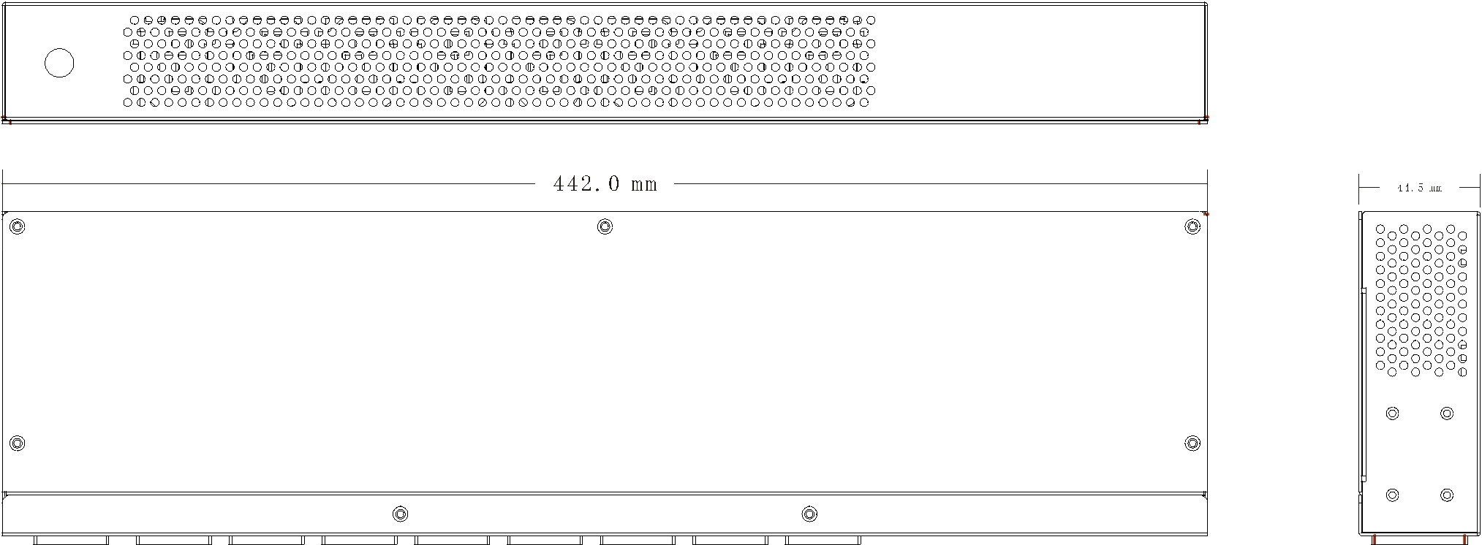


1 2 3 4 5 6 7

Instructions

1、 Power Input Socket IEC320 C20

2、 Output Socket IEC C13

3、 Reset Key

4、 Function Key, Check the machine IP address

5、 Meter Panel, Display voltage, current, temperature, humidity, etc 6、 Temperature and humidity sensor

7、 Network Port, Connect LAN or WAN

Using Directions:

1. Equipment connection Connect LIU - 0816-8 IEC C13 output plug with one side of the output line,

2 / 7
connect 8 output line respectively with the power input end of the server which needs power supply. Connect one side of input line plug with the LIU - 0816 - WN IEC320 C20 input socket, and the other side with the AC power supply socket. After that, LIU - 0816 - WN will start from the first port to the 8th port with interval of 1 second, and supply power for the server. Display panel will show the current supply voltage and total output current of 8 circuits, 8 LED indicator light indicates the state of current 8 output port.

- Check the IP address The display will show LIU - 0816 - current IP address after pressing the FUNC button when the display shows the voltage and current. The default IP address is 192.168.0.10
- Check the temperature and humidity The display will show temperature and humidity of LIU - 0816 - WN built-in temperature and humidity sensor after pressing the FUNC button in the state of screen shows the IP address. The left screen shows temperature and the right screen shows humidity.

- Reset of the equipment Press the LIU - 0816 - WN RST button on the front panel, it will reset .

- Network access and control With LIU - 0816 - WN power-on, users can achieve the function that PC host access and control LIU - 0816 - WN in the same LAN by connecting RJ45 socket with network
①. Login control interface Open the IE browser on any PC in LAN host, the address bar:

Http://192.168.0.100 , uses can login LIU - 0816 - WN control interface after inputting user name (admin), password (admin) in the jumped login screen as shown in the picture below.
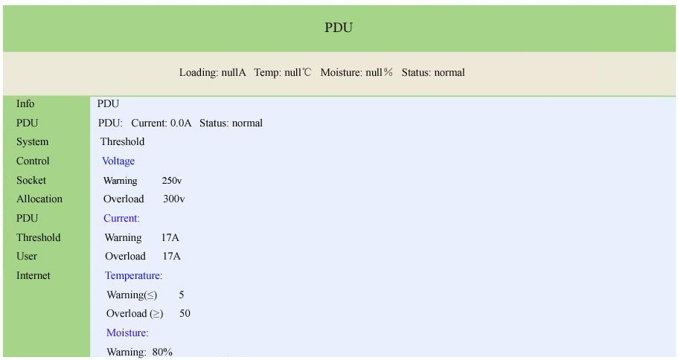

②. PDU system information Click the "System" on the left side of the information bar, to indicate the PDU system information as the following picture.

3 / 7

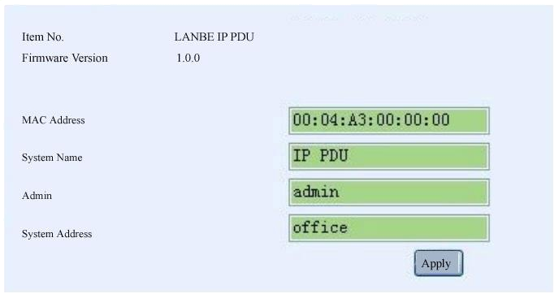

③. The power port control Click "Socket" in the control bar which is on the left side of the interface , display as shown below.
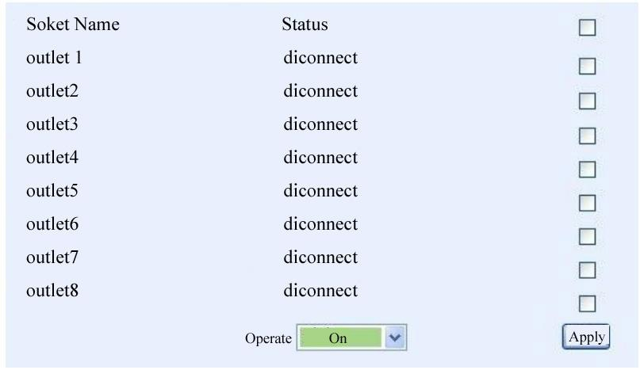

Users can start or shut off LIU - 0816 - WN 8-way output in this interface.

Start all: click drop-down box behind the action box, choose “Start”, click the “Apply” button

Shut off all : click drop-down box behind the action box, choose “Shut off”, click the “Apply” button

Custom start and shut off : illustrate the method of custom start and shut off, if the user needs to start 1, 2, 3,

4 circuit, but shut off 5, 6, 7, 8, the first method: click the drop-down box behind the action box, choose “Start”. And then, click the small box behind outlet1, outlet2, outlet3, outlet4 respectively, click “Apply” button. The second method: click the drop-down box behind the action box, choose “Shut off ”. And then, click the small box behind outlet5, outlet6, outlet7, outlet8 respectively, click “Apply” button.

④. Start and shut off time-delay Click “PDU” in the configuration box which is on the left side of the interface, display interface as shown below.

4 / 7

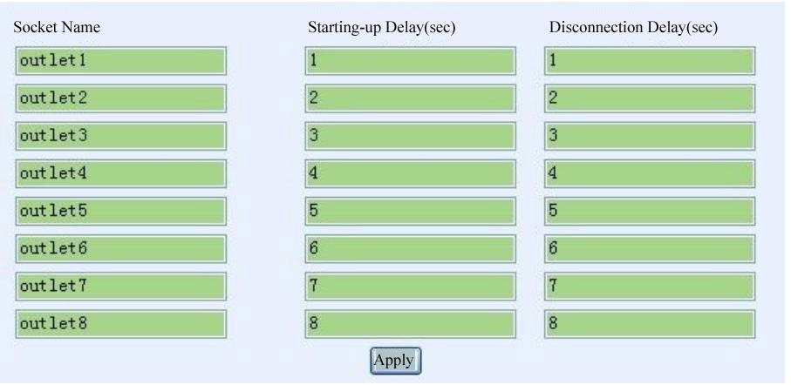

Users can start or shut off time-delay of LIU - 0816 - WN 8-way output. The picture above is the factory Settings, it means that the 8 circuit of LIU - 0816 - WN will output from the 1st to the 8th port in sequence in the interval of one second after connecting with power. When open the 8 output through the network, the starting delay time will display on the 8 output port. It is important to note that when the user disconnect the input power of LIU - 0816 - WN, shutting off the time-delay function is invalid. Shutting off the time-delay function is only applicable to control 8-way output through a network.

⑤. Threshold value setting Click “Threshold value” in the configuration box which is on the left side of the interface, display interface as shown below.
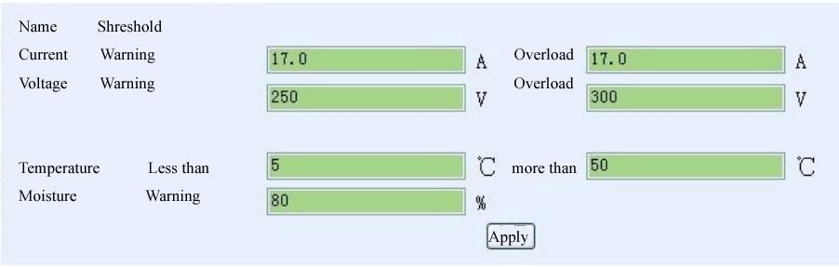

The picture above is the factory Settings, the meaning is:

Current warning value 17A: When the total current exceeds 17A, LIU - 0816 - WN buzzer sends out "beep, beep" sound alarm

Current overload value 17A: When the total current exceeds 17 a, LIU - 0816 - WN will cut off the power supply of all output port

Warning voltage 250V: When the input voltage exceeds 250V, LIU - 0816 - WN buzzer sends out "beep, beep" sound alarm

Current overload value 300V: When the input voltage exceeds 300V, LIU - 0816 - WN cut off the power supply of all output port

Temperature is under 5 ℃, or exceed 50 ℃: When LIU - 0816 - WN built-in temperature and humidity sensor sensing the environment temperature is under 5 ℃ or exceed 50 ℃, LIU - 0816 - WN buzzer sends out "beep, beep" sound alarm

Humidity warning value 80%: When LIU - 0816 - WN built-in temperature and humidity sensor sensing environment humidity is more than 80%, LIU - 0816 - WN buzzer sends out "beep, beep" sound alarm

⑥. The user name and password setting Click “user” in the configuration box which is on the left side of the interface, display interface as shown below.
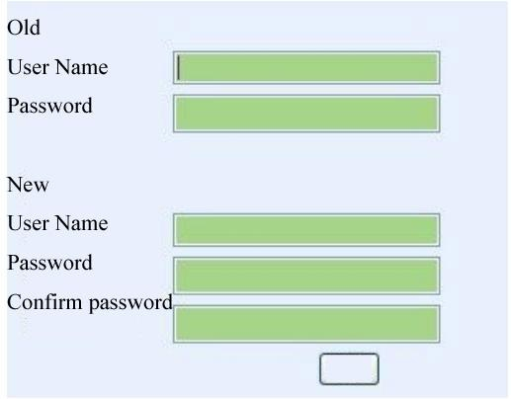

The login user name and password of LIU - 0816 - WN can be modified in this interface. After filling in the original and new user name, password and password confirmation respectively, click apply button, the new user name and password will be used at the next time login LIU - 0816 - WN.

⑦. IP address and DNS Setting. Click “network” in the configuration box which is on the left side of the interface, display interface as shown below.
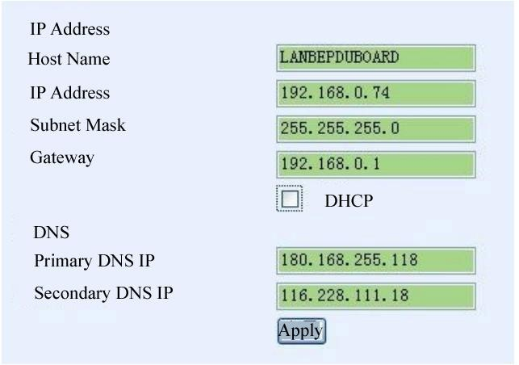

6 / 7

Host name: The name showed in the LAN, users can set itself

IP address: The current LAN IP address of LIU - 0816 - WN

Subnet mask: The current LAN subnet mask of LIU - 0816 - WN

Gateway: The current gateway of LIU - 0816 - WN

Enable the DHCP: The superior router of the current LAN will distribute network parameters automatically for LIU - 0816 - WN, it will come into force after clicking the apply button

Primary DNS IP refer to the supervisor router setting of current LAN Secondary DNS IP refer to the supervisor router setting of current LAN

7 / 7

